**Animations**

**What is an animation?**

**Animation** is where a series of still images are linked together as part of a timed sequence. This makes the image appear to move. This is the same technique used when making cartoons.

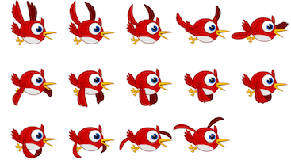

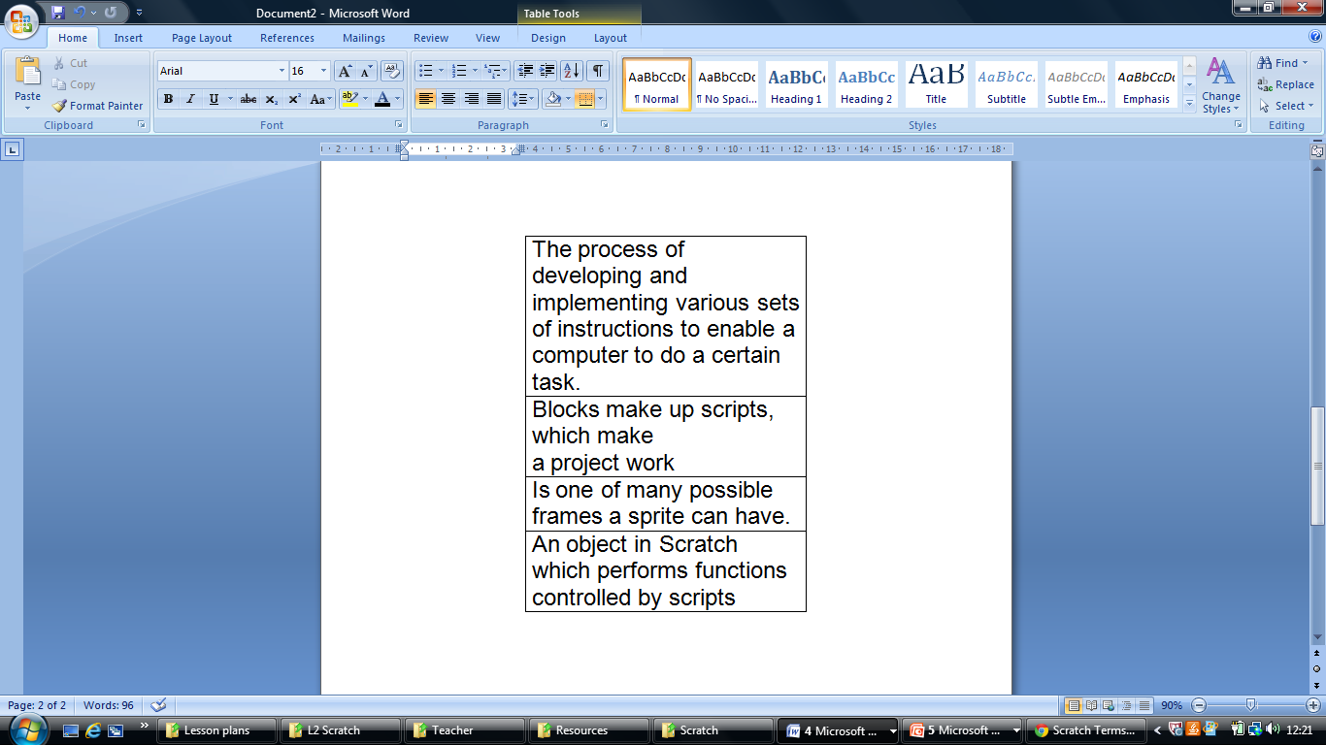Match the words with the definitions

|  |
| --- |
| Sprite |
| Costume |
| Programming |
| Blocks |